

Novel ‘Twist’ Syringe

Designing a 3D printable syringe for long-term space missions, as well as far-flung areas of the Earth, comes with a number of challenges.

1. The potential advantages and disadvantages of current solutions must be taken into account.
2. The parts that can effectively be printed must be decided.
   1. For a syringe, the metal needle cannot be printed cheaply with current technologies, but the needles themselves can be packed efficiently in a small volume, and as such can be included on a mission in a large number.
   2. The rubber plug that keeps the syringe air and watertight cannot be easily printed.
3. The design should allow the 3D syringe to work near/or as effectively as current terrestrial versions.
4. The design should be simple to print and use.

The solution to these challenges presented itself as a novel idea involving the threading of the inside of the syringe body and with it, the outside of the plunger. This threading will make administering shots, or taking blood samples, extremely easy in microgravity, freefall, or hostile conditions, while still maintaining water and air tightness. The astronaut will be able to control the syringe with extreme precision and will only be limited by the speed of injection relative to terrestrial counter parts. A critical advantage of our system is that threading is not difficult to print for current ‘off the shelf’ 3D printers.

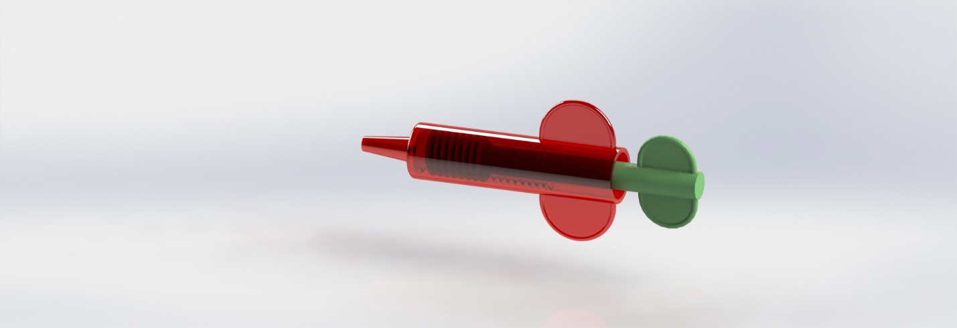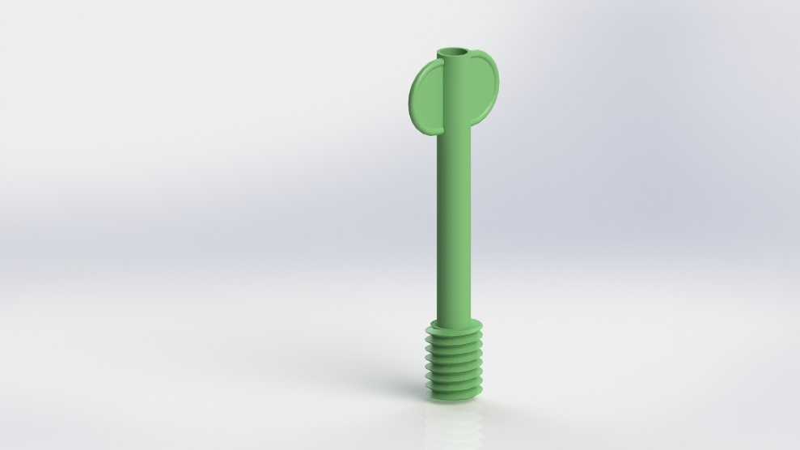The 3D printing process allows for the fabrication, and re-fabrication, of the medical kit when supplies present on the mission at the start begin to run low. An added benefit of the re-fabrication (melting and reusing) of the 3D printed part is the temperature at which the process needs to take place is hot enough to completely sterilize the material. Thus, making it safe for an infinite number of reuses. This also allows for creating the exact number of medical components that are needed in a potential medical emergency.

